25 November 2025

DR. TRISTAN L. ABANDO
Regional Director
Department of Science and Technology
Regional Office No. VII
Lahug S&T Complex, Sudlon, Lahug
Cebu City 6000

Dear Dr. Abando:

Greetings from the Research Center for Theoretical Physics of the Central Visayan Institute Foundation (RCTP-CVIF).

We respectfully express our intent to apply for support under the DOST Grants in Aid Program of Region VII for our project titled “Establishing RadioJOVE and SkyNet for Astronomical and Exoplanet Research: Application of White Noise Analysis of Curated Datasets”.

Through our recent linkages with visiting astrophysicists, we have gained access to a research framework that is new in the Philippine setting. This includes the use of SkyNet Robotic Telescopes for optical observations and the RadioJOVE system for radio astronomy. These tools allow focused work on exoplanet transits, radio emissions from the Sun and Jupiter, and data processing related to astronomy and astrophysics.

To ensure sustainability, we plan to integrate this effort with the CVIF Dynamic Learning Program. This will support outreach activities and training workshops for faculty and students. The goal is to build long-term capability in astronomy, astrophysics, and data science within Central Visayas and to create a pathway for young learners to enter emerging scientific fields.

We believe this project aligns with the goals of DOST in strengthening regional research capability, supporting new areas of scientific work, and promoting practical training in STEM. We respectfully request the opportunity to submit our full proposal for your consideration.

Thank you very much for your time.

Sincerely yours,
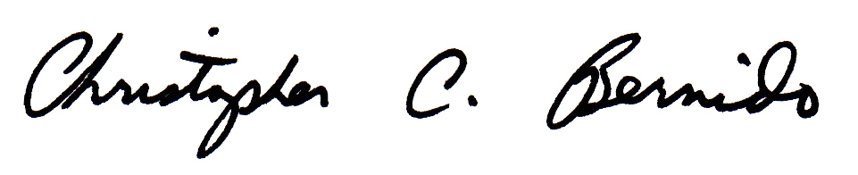

Christopher C. Bernido, Ph.D.
Project Leader

